Your group needs to decide what kind of project you are going to work on and lock in your decision. You need to submit a free style paper that describes your project on a high level. Please cover the following questions:

1. What are you building?

A connection website application for people to find others to form groups to play board games with and organise times to play.

This website acts as a socialising network for board game lovers. It creates an environment to cultivate new friendships through gaming. The users can organise to play against each other or work cooperatively in a team.

2. What does it do or what kind of problem does it solve?

Playing board games can be an expensive hobby. It can also be difficult to find people available to play games. This website helps people to find other people with similar table top interests to connect and play board games with.

Studies have shown that online gamers forge genuine and enduring friendships while competing with strangers they’ve met over the internet (Griffiths, Davies, Chappell, 2003). During the pandemic there was a massive increase in the gaming industry which coincided with the increased feelings of isolation, loneliness and mental health struggles. Many found an outlet through gaming and gained solace.

In addition to the already existing table top community, board games have always been a staple in many households since childhood. However, few continue to play it as they get older or move away from their families. It ultimately becomes a nostalgic game. We intend to bring the board game experience to the masses and facilitate reconnection for people who enjoy playing them.

This ultimately solves three problems by:

1. Creating opportunities for people to socialise and network via gaming
2. Facilitate engagement with the online world, using gaming as a means to eliminate loneliness
3. Helping people discover new games as well as old favourites that have been lost to time

3. What are the key features of your system?

1. A user will create an account/login.
2. The user is able to build out their profile by adding a list of board games they like or are interested in playing (optional) - this can be useful for the future, to make algorithms to connect people via their interests or to provide game recommendations.
3. The user is able to select (from options) the game they wish to play followed by the time. If a group has already been formed for this time they can join and view a summary of the game and usernames of others in the group, if not they can host the game.
4. Users can host a game session by creating a page with information about the game (title, description, minimum players, maximum players), and a given time that the host is available to play said game.
5. Other users will be presented with available games and can search this list of game sessions by game title or by time and date. The players will be able to join a game session with other players and be directed to where online (or possibly in person) they can play this game.

4. Provide a sample architecture diagram of your system (you can use PPT with squares and circles to demonstrate a simplified flow of your system):

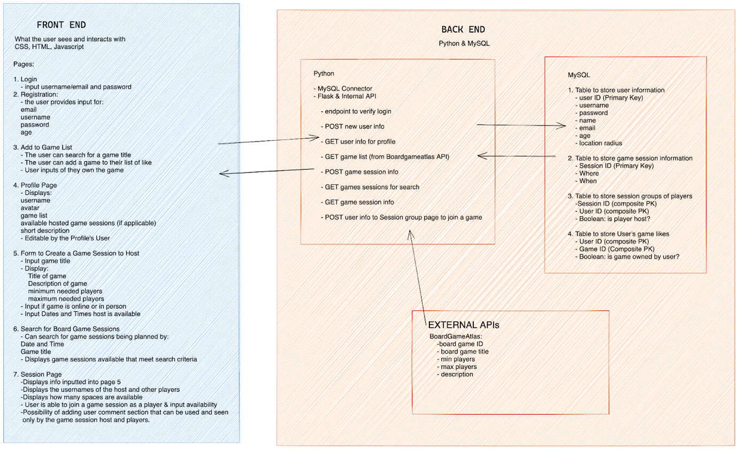

Front end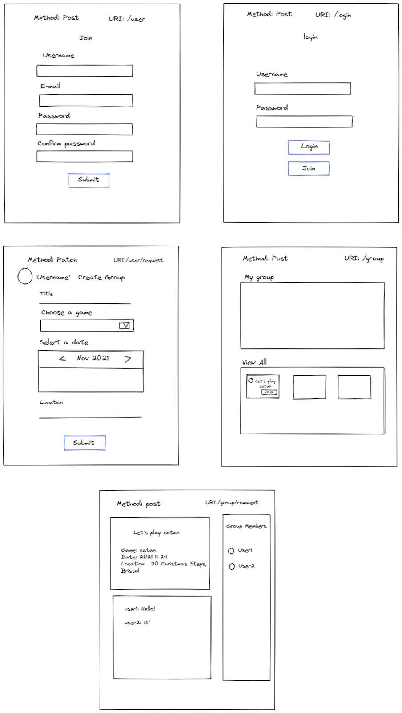

5. Describe the team approach to the project work: how are you planning to distribute the workload, how are you managing your code, how are you planning to test your system.

Distribution:

We are planning to distribute each architectural section between us. Initially we are divided the work out as followed:

* Sinhye will lead the front end development with Nadine helping.
* Nadine and Ada will lead the Flask and Internal API files as well as connecting the external API to our web application.
* Samantha will create the database.
* Bethan will lead the MySQL connector file.

Every Monday, Wednesday, Friday we will have zoom meetings for an hour in the mornings to talk through what has been done, explaining the code to the rest of the team, as well as discuss any problems and what will be done next. We will also keep the roles a little flexible, knowing that as the project evolves our roles and jobs may as well.

Code Management:

* GitHub repository - each using different branches (not main)
* Group trello board to plan and keep track of work
* Zoom meetings 7:45am Monday, Wednesday, Friday to act as ‘sprint planning’ meetings to collaborate and keep track of our progress
* Slack channel for regular communication and updates

Testing :

* Mocking data to fill the DB/create pre-existing groups of games for users to join
* Unit Testing
* User testing (UAT) - everyone in the group will act as the user and step through creating a login, select interests, make and join various board game groups

\*\*What do we think the future holds for this application?

This project, in the future, can expand to have:

* chat and video calling features
* algorithms to suggest games to play and/or people who enjoy the similar games as the user already
* Features in the website to search for board game friendly cafes and pubs within a search radius for people who want to play in person in a public space
* Provide more structured scheduling system where a group can give ranges of time availability and an algorithm would display the best time
* use user locations (with permission) to plan our create group meet-ups for in-person gaming
* housing actual board games on the site for online board gaming
* Generating virtual meet-up (eg. zoom) code for the game groups to socialise whilst playing board games online

Potential expansion ideas for the future prototype:

